Try deleting a member who:
• Has existing loans
• Has written book reviews

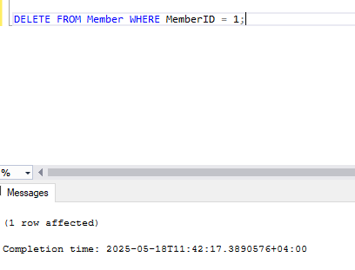
The Member table has a foreign key constraint (ON DELETE CASCADE) with the Loan table. However, since the member has active loans, the database prevents deletion to maintain referential integrity.

Try deleting a book that:
• Is currently on loan
• Has multiple reviews attached to it
Error Message
The DELETE statement conflicted with the REFERENCE constraint "FK_Loan_Book".
The conflict occurred in database "LibraryManagementSystem", table "dbo.Loan", column 'BookID'.

Problem: Books can't be deleted when referenced elsewhere.
Solution Strategy:
- Inventory Management Approach
  - Mark books as "Withdrawn" instead of deleting
  - Update status to prevent new loans while preserving history
- End-of-Life Process
  - First return all copies (update loan status)
  - Migrate reviews to a "Retired Books" table
  - Then remove from active inventory

Try inserting a loan for:
• A member who doesn’t exist
• A book that doesn’t exist

The INSERT statement conflicted with the FOREIGN KEY constraint "FK_Loan_Member".
The conflict occurred in database "LibraryManagementSystem", table "dbo.Member", column 'MemberID'.

Problem: Loans for non-existent members/books.
Solution Strategy:
- Pre-validation System
  - Application layer must verify existence before loan creation
  - Real-time checks during form submission
- Reservation Workflow
  - Implement "hold" system for unavailable items
  - Prevent submission until all conditions are met

Try inserting a payment with:
• A zero or negative amount
• A missing payment method

The INSERT statement conflicted with the CHECK constraint "CK__Payment__Amount__[some_hash]".
The conflict occurred in database "LibraryManagementSystem", table "dbo.Payment", column 'Amount'.

Problem: Invalid payment amounts/methods.
Solution Strategy:
- Client-Side Validation
  - Form validation for positive amounts
  - Required field enforcement for payment method
- Payment Verification Step
  - Review screen showing payment summary
  - Confirmation requirement before processing

Try inserting a review for:
• A book that does not exist
• A member who was never registered

The INSERT statement conflicted with the FOREIGN KEY constraint "FK_Review_Book".
The conflict occurred in database "LibraryManagementSystem", table "dbo.Book", column 'BookID'.

Problem: Reviews for non-existent books/members.
Solution Strategy:
- Eligibility Verification
  - Only allow reviews from members who borrowed the book
  - Verify book exists before review submission
- Post-Return Review Period
  - Enable review option only after loan return
  - Time-limited window (e.g., 30 days post-return)

